Vertical Kids Entertainment – Corporate Christmas

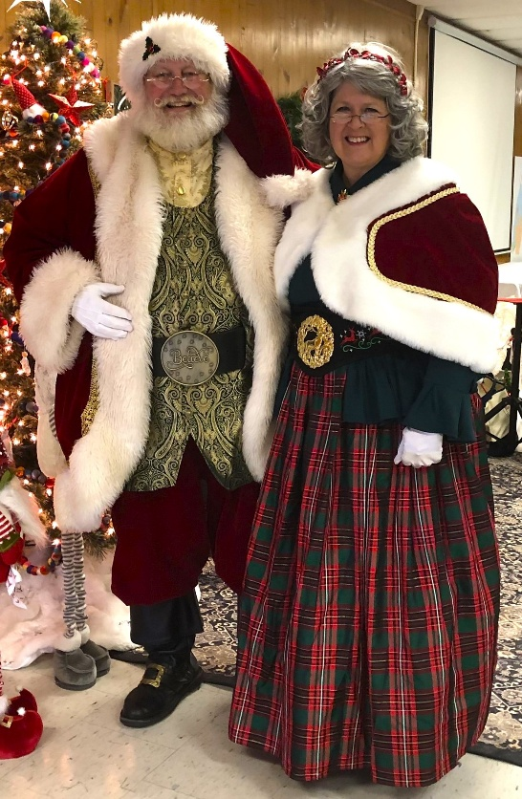
Santa Contract Agreement:
To guarantee rates and terms quoted, this Agreement must be signed and returned to Earl Long (hereinafter Known as Santa), by Date (_______) First and foremost, it is both an honor and a privilege to be your Santa Claus this year. I do not regard this appointment as merely a performance; it is an honor, responsibility, and privilege. I appreciate the trust you have placed in me, and will do my very best to make you happy you did. We have agreed upon a fee of ($_______ ) to be handed to Santa in currency or by check at the conclusion of the performance as he exits. However, please pay whatever you think the performance was worth, more or less. Please make checks payable to Vertical Kids Entertainment. Since it is not appropriate for Santa to be seen accepting money, please place payment and gratuity inside a Christmas card or envelope and present to Santa. There is also a 50% non-refundable retainer fee to be paid at the time of booking. (This can be made by credit card or check.) Check mailed to PO Box 66662 Virginia Beach, VA 23466.
Home parties, corporate events and special events are a minimum one-hour. For home or private visits Santa will arrive within a +/- 30-minute window of scheduled time due to traffic or other unforeseeable circumstances. A break of ten minutes after each full hour of work is appropriate. A little cool water is always welcome. For Special Events, Santa will arrive approximately 10 minutes prior to appearance unless otherwise stipulated in this Agreement. All rates quoted include mileage within a 25-mile radius of 260 Kenley Rd. Virginia Beach, VA 23462. If more than 25 miles, there is a mileage fee. All costumes are standard Holiday dress. The “Santa Look” for your event is labeled. Special requests are at the client’s cost and should be made to Santa in advance. Due to the nature of Santa’s traditional outfits, it is necessary that he have periodic breaks and that his performance location be cool and comfortable, we recommend 65° - 70°. It is assumed that all events will be indoors, or that arrangements have been made if event is held outdoors, and therefore cancellations due to inclement weather are not accepted. Any and all photos taken of Santa, whether by individuals or professional photographers, are to be for private or personal use of the client and may not be used for commercial or promotions use without written permission of Santa. (No smoking or fire pits in vicinity of Santa)

Santa and Mrs. Claus
Look For Your Event

Event: ________________________________________________
Date: _________________ Time of Event: _______ until ___________
Location: ______________________________________________
EVENT DETAILS or Special Instructions
(i.e, breakfast, photos, attendees w/special needs, walk about greeting people, story time, adult only, )
____________________________________________________________________________________________________________________________________________________________________________________________________
I have read the above Agreement and agree to its Terms and Conditions. I understand that this booking will remain tentative, subject to cancellation by Santa, until the signed Agreement is received.
Client: _______________________________________________________ Date signed: ______________________
(ENTER NAME OF CLIENT)
Santa: ________Santa Earl__________________________________ Date signed: ________________

Santa Earl Long – PO Box 66662 Virginia Beach, VA 23466 Cell Phone: 757-270-4581
Email: verticalkidsministry@gmail.com http://SantaEarl.com
-Page One of Two-
Invoice and Booking Confirmation for Santa Earl Long:

Client’s Name: ___________________________________________________________________________________________
Day/Date: ____________________________ Time of Event: __________ To ___________ Attendance #:____________
Entertainer’s Time Period: _____________________________ Event: _________________________________________________
Event Address: _________________________________________________________________________
City/State/Zip: ____________________________________________________________________________
Phone Numbers and Emails:
Event Coordinator’s Name: _______________________________________________________
Email: _ ________________________ Phone number of event coordinator: Cell: ________________ Work: ____________
Back-up person for Event Coordinator: Name: ______________________________________________________
Email: ____________________ Phone number of back-up coordinator: Cell: ________________ Work: _____________
Event Details: Please check off and fill in what you will provide for Santa at your event
- Example: Host will provide photographer
- Example: Host will provide assistants to help with controlling families and children
- Example: Host will provide favors for Santa to hand out to children
- Example: Host will provide a sturdy 4-legged chair for Santa for any seated visitation
- Example: Host will have presents to hand out to the kids
- Other ___________________________________________________________________
___________ Santa’s Believe in The Magic of Christmas Show – One Hour or up to One-Hour Show = Fee $625

Santa Total Time: ________* Mon. – Fri. before 4 PM $275 per hour
________* After 4 PM Weekdays & Sat. - Sun. $300 per hour.
________*Dec. 24 Christmas Eve - $325 per hour
(Fill in hours)
(Mrs. Claus, Olaf, Grinch or Elf) ______(Fill in hours) X $225.00 per hour per entertainer
Olaf Dance Party with Games and Music ______(Fill in hours) x $275 per hour
Total for other entertainer $__________ (Fill in amount)

Travel Expenses: If the event is within 25 miles of their home area of 260 Kenley Rd. Virginia Beach, VA 23462 = no travel fee. Travel fees: 26-35 miles = $40 / 36-50 miles = $80 / 51-60 miles = $110 / 61-75 miles = $125
76-100 miles = $150 / Over 100 miles = $2.00 per mile

Event Fee $__________ (Expenses, Mileage Fee) $_______.00 (Total) $________.00
Retention Fee: 50% of total fee ________________ Date paid ____________


Remaining payment of $____________ in cash or check is due at end of visit payable to Vertical Kids Entertainment. If paying by credit card a 3.5% fee will be added.
Client’s initials: _____________ Santa’s initials: ____________
Date: _____________________ Date: ____________________
Santa Earl Long – PO Box 66662 Virginia Beach, VA 23466 Cell Phone: 757-270-4581
Email: verticalkidsministry@gmail.com http://SantaEarl.com
-Page Two of Two-

